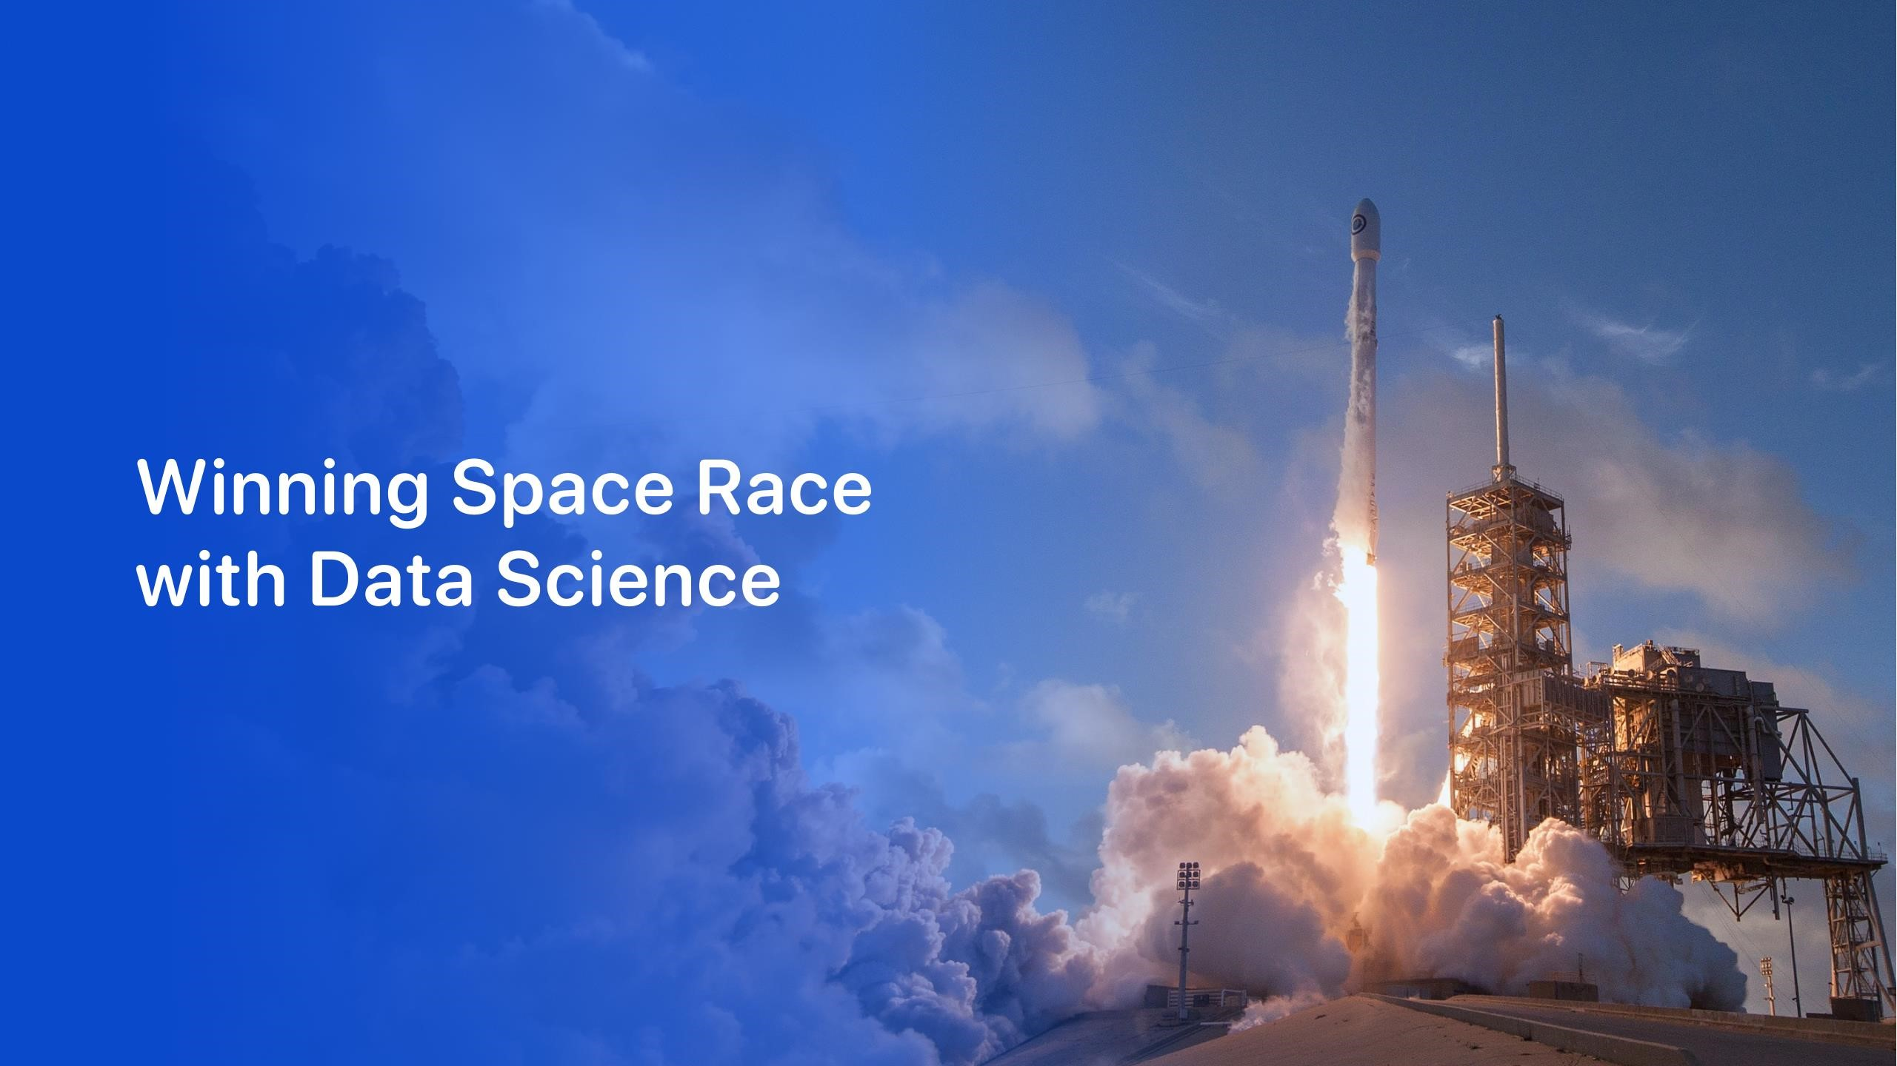

Mohd Amadur Rahman Maher

24

December

2022

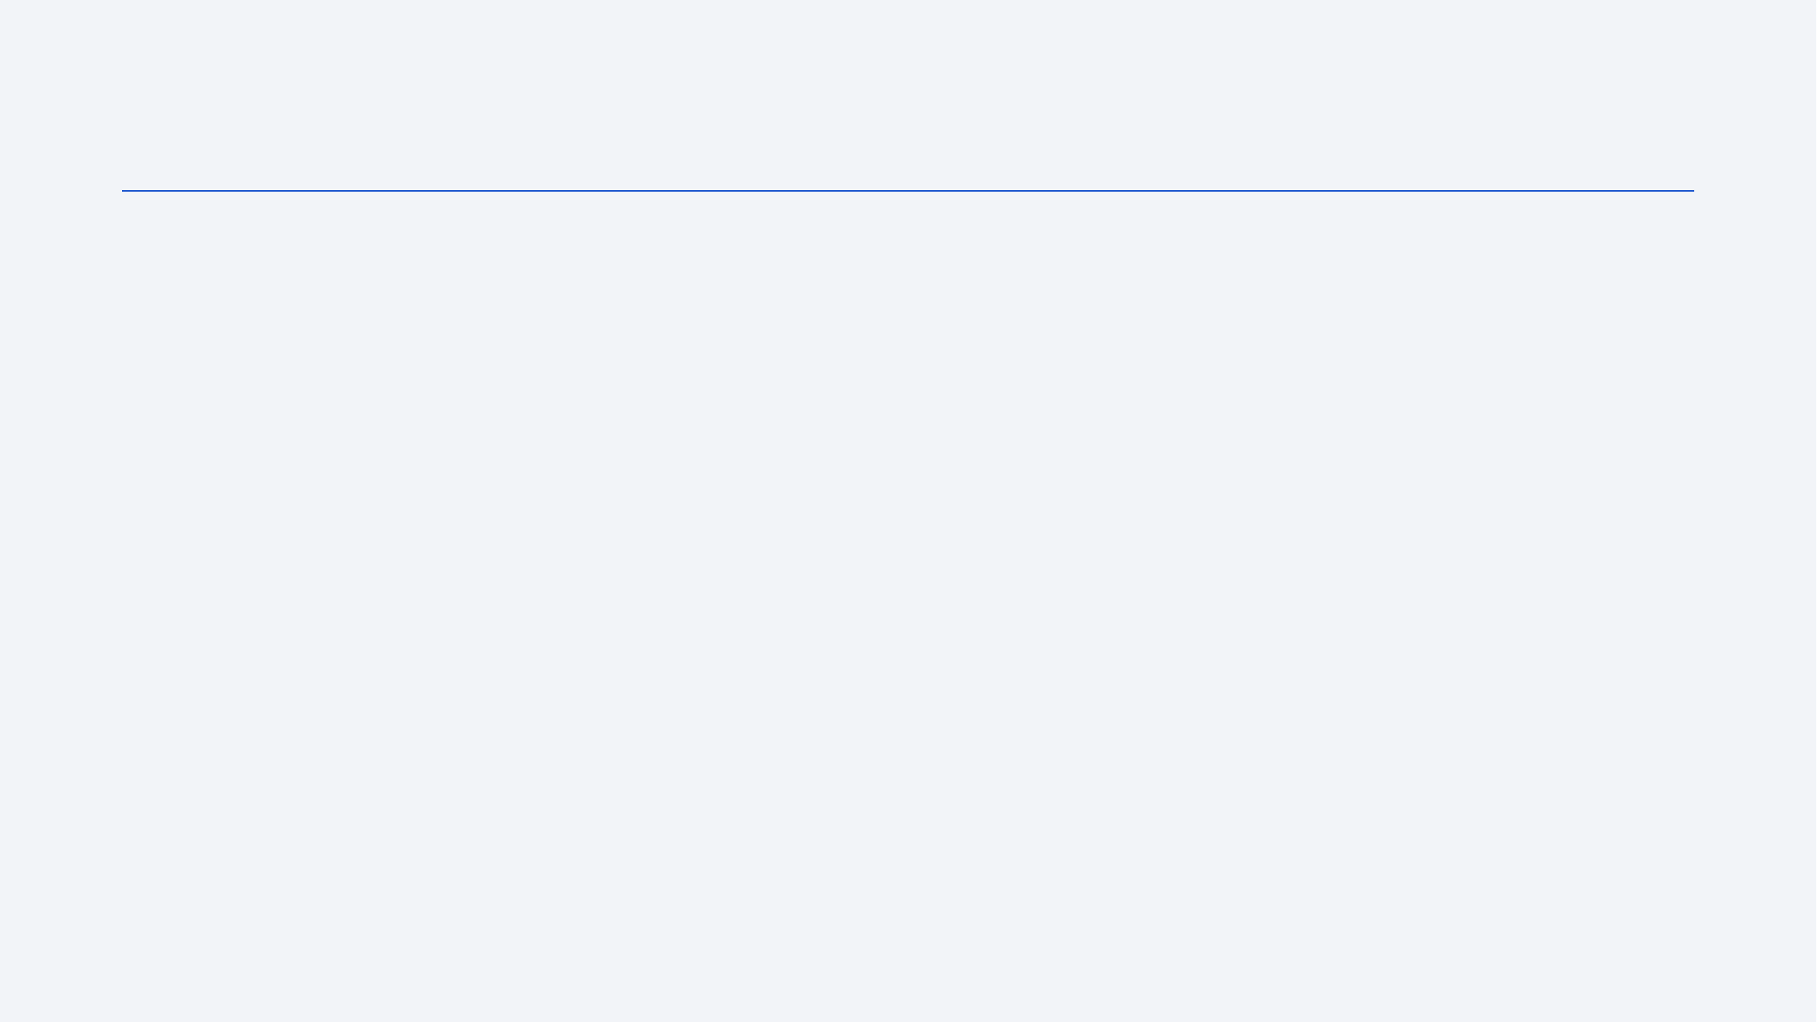

•

Executive Summary

•

Introduction

•

Methodology

•

Results

•

Conclusion

•

Appendix

Outline



3

•

Summary of

methodologies

-

SpaceX Data

Collection

using SpaceX

API

-

SpaceX Data Collection with Web Scraping

-

SpaceX Data

Wrangling

-

SpaceX Exploratory

Data Analysis

using

SQL

-

Space

-

X EDA DataViz Using

Python Pandas

and

Matplotlib

-

Space

-

X Launch Sites

Analysis

with Folium

-

Interactive Visual

Analytics and

Ploty

Dash

-

SpaceX Machine Learning

Landing Prediction

•

Summary of all

results

-

EDA results

-

Interactive Visual Analytics and

Dashboards

-

Predictive Analysis(Classification)

Executive Summary



Introduction

•

Project background and

context

SpaceX advertises Falcon 9 rocket launches on its

website with a cost of 62 million dollars; other providers

cost upward of 165 million dollars each, much of the

savings is because SpaceX can reuse the first stage.

Therefore if we can determine if the first stage will land,

we can determine the cost of a launch. This information

can be used if an alternate company wants to bid

against SpaceX for a rocket launch

.

•

Problems you want to find

answers

In this capstone, we will predict if the Falcon 9 first

stage will land

successfully

using

data from Falcon

9

rocket launches

advertised on

its

website.

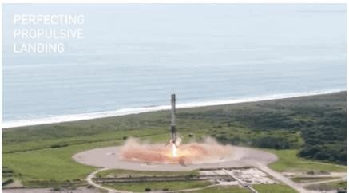

5

Section 1



Executive Summary

•

Data collection methodology:

•

Describes

how data sets were collected

•

Perform data

wrangling

•

Describes

how data were

processed

•

Perform

exploratory data analysis (EDA) using visualization and

SQL

•

Perform interactive visual analytics using Folium and

Plotly

Dash

•

Perform predictive analysis using classification models

•

How to build, tune, evaluate classification models

Methodology

# Data Collection

* Description of how SpaceX Falcon9 data was collected.
* Data was first collected using SpaceX API (a RESTful API) by making a get request to the SpaceX API. This was done by first defining a series helper functions that would help in the use of the API to extract information using identification numbers in the launch data and then requesting rocket launch data from the SpaceX API url.
* Finally to make the requested JSON results more consistent, the SpaceX launch data was requested and parsed using the GET request and then decoded the response content as a Json result which was then converted into a Pandas data frame.
* Also performed web scraping to collect Falcon 9 historical launch records from a Wikipedia page titled [List of Falcon 9 and Falcon Heavy launches](https://en.wikipedia.org/wiki/List_of_Falcon_9_and_Falcon_Heavy_launches) of the launch records are stored in a HTML. Using BeautifulSoup and request Libraries, I extract the Falcon 9 launch HTML table records from the Wikipedia page, Parsed the table and converted it into a Pandas data frame



Place your flowchart of SpaceX API calls

here

•

Data collected

using SpaceX API (a

RESTful API) by making a get request

to the SpaceX

API then requested

and

parsed the SpaceX launch data using

the GET request and

decoded

the

response content as a

Json

result

which was then converted into a

Pandas data frame

•

Here is the GitHub

URL of the

completed SpaceX API calls notebook

(

https://github.com/cgatama/SpaceX

-

Falcon

-

9

-

1

st

-

stage

-

Success

-

Landing

-

Prediction/blob/main/1.%20Space

-

X%20Data%20Collection%20API.ipynb

)

Data Collection

–

SpaceX API

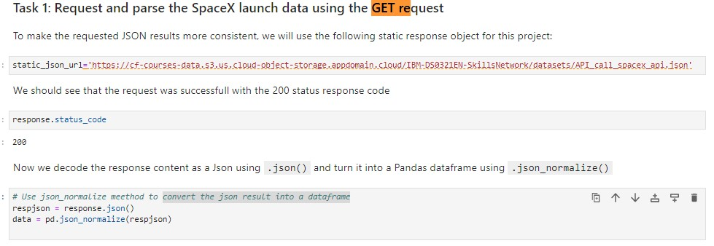

•

Performed

web scraping to collect

Falcon 9 historical launch records

from a

Wikipedia using

BeautifulSoup

and

request, to

extract the Falcon 9 launch

records

from HTML

table

of the

Wikipedia

page,

then created

a

data frame by parsing the launch

HTML.

[•](https://github.com/cgatama/SpaceX-Falcon-9-1st-stage-Success-Landing-Prediction/blob/main/2.%20Space-X%20Web%20scraping%20Falcon%209%20and%20Falcon%20Heavy%20Launches%20Records%20from%20Wikipedia.ipynb)

[Here](https://github.com/cgatama/SpaceX-Falcon-9-1st-stage-Success-Landing-Prediction/blob/main/2.%20Space-X%20Web%20scraping%20Falcon%209%20and%20Falcon%20Heavy%20Launches%20Records%20from%20Wikipedia.ipynb)

is the

GitHub URL of the

completed web scraping

notebook.

•

(

https://github.com/cgatama/SpaceX

-

Falcon

-

9

-

st

1

-

stage

-

Success

-

Landing

-

Prediction/blob/main/2.%20Space

-

X%20Web%20scraping%20Falcon%209%20and%2

0

Falcon%20Heavy%20Launches%20Records%20fr

om%20Wikipedia.ipynb

)

Data Collection

-

WebScraping

Place your flowchart of web scraping here

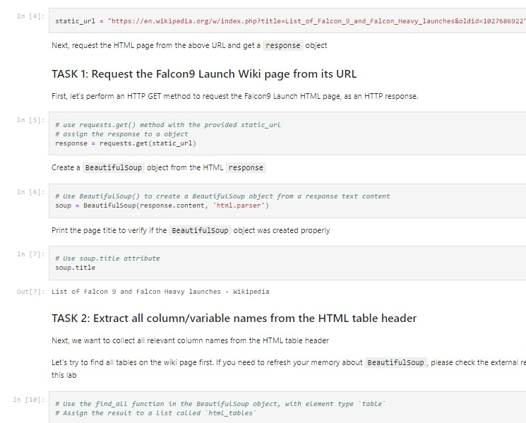

•

After obtaining and creating a Pandas DF from

the collected data, data was filtered using the

BoosterVersion

column to only keep the

Falcon 9 launches, then dealt with the missing

data values in the

LandingPad

and

PayloadMass

columns. For the

PayloadMass

,

missing data values were replaced using mean

value of column.

•

Also performed

some Exploratory Data

Analysis (EDA) to find some patterns in the

data and determine what would be the label for

training supervised models

[•](https://github.com/cgatama/SpaceX-Falcon-9-1st-stage-Success-Landing-Prediction/blob/main/3.%20Space-X%20Data%20Wrangling%20spacex.ipynb)

[Here](https://github.com/cgatama/SpaceX-Falcon-9-1st-stage-Success-Landing-Prediction/blob/main/3.%20Space-X%20Data%20Wrangling%20spacex.ipynb)

is the GitHub

URL of

the completed

data

wrangling related

notebooks.

Data Wrangling

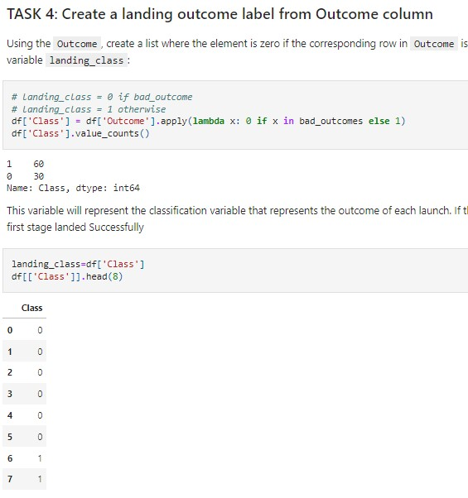

•

P

erformed

data

Analysis and Feature Engineering using Pandas and

Matplotlib.i.e

.

•

Exploratory

Data Analysis

•

Preparing Data Feature Engineering

•

Used scatter plots to Visualize the relationship between Flight Number and Launch

Site

, Payload and Launch Site,

FlightNumber

and Orbit type, Payload and Orbit

type.

•

Used Bar chart

to Visualize the relationship between success rate of each orbit

type

•

Line plot to Visualize

the launch success yearly

trend.

[•](https://github.com/cgatama/SpaceX-Falcon-9-1st-stage-Success-Landing-Prediction/blob/main/5.%20Space-X%20EDA%20DataViz%20Using%20Pandas%20and%20Matplotlib%20-%20SpaceX.ipynb)

[Here](https://github.com/cgatama/SpaceX-Falcon-9-1st-stage-Success-Landing-Prediction/blob/main/5.%20Space-X%20EDA%20DataViz%20Using%20Pandas%20and%20Matplotlib%20-%20SpaceX.ipynb)

is

the GitHub URL of your completed EDA with data visualization notebook,

(

https://github.com/cgatama/SpaceX

-

Falcon

-

9

-

1

st

-

stage

-

Success

-

Landing

-

Prediction/blob/main/5.%20Space

-

X%20EDA%20DataViz%20Using%20Pandas%20and%20Matplotlib%20

-

%20SpaceX.ipynb

)

EDA with Data Visualization



EDA with Data

Visualization (Plots

Cont

….)

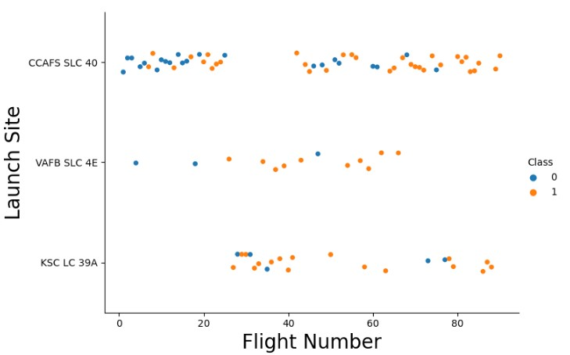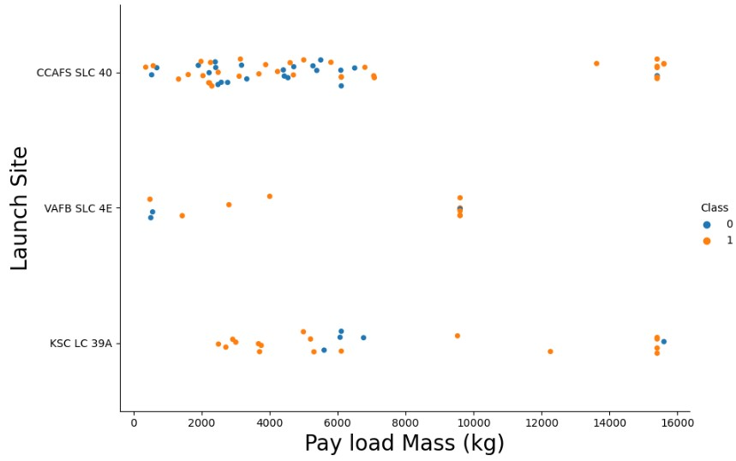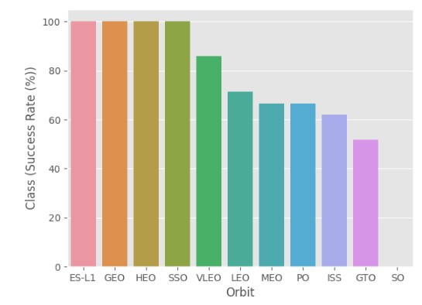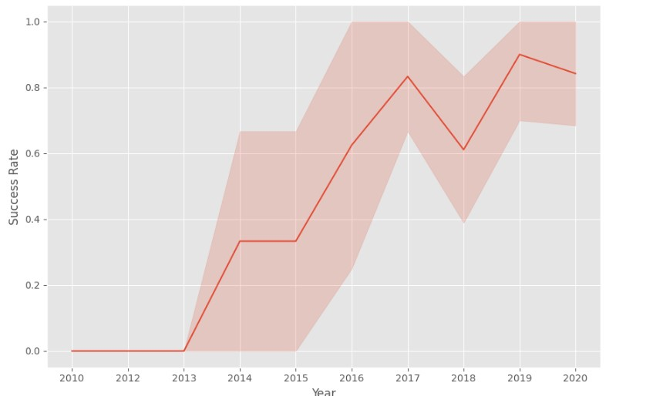

•

The following SQL

queries

were performed for EDA

•

Display the names of the unique launch sites in the space

mission

•

Display 5 records where launch sites begin with the string

'CCA‘

•

Display the total payload mass carried by boosters launched by NASA (CRS)

•

Display average payload mass carried by booster version F9

v1.1

EDA with

SQL



•

List the date when the first

successful

landing outcome in ground pad was

achieved

•

List the names of the boosters which have success in drone ship and have payload

mass greater than 4000 but less than 6000

(

%

sql

SELECT DISTINCT

Booster_Version

, Payload

FROM SPACEXTBL WHERE "Landing _Outcome" = "Success (drone ship)" AND PAYLOAD_MASS__KG_ >

< 6000

4000

AND PAYLOAD_MASS__KG_

;)

•

List the total number of successful and failure mission

outcomes

[•](https://github.com/cgatama/SpaceX-Falcon-9-1st-stage-Success-Landing-Prediction/blob/main/4.%20Space-X%20EDA%20Using%20SQL.ipynb)

[Here](https://github.com/cgatama/SpaceX-Falcon-9-1st-stage-Success-Landing-Prediction/blob/main/4.%20Space-X%20EDA%20Using%20SQL.ipynb)

is the GitHub

URL of your completed EDA with SQL

notebook.

(

https://github.com/cgatama/SpaceX

-

Falcon

-

9

-

1

st

-

stage

-

Success

-

Landing

-

Prediction/blob/main/4.%20Space

-

X%20EDA%20Using%20SQL.ipynb

)

EDA with

SQL (Cont.…)



•

C

reated

folium map to marked all the launch

sites, and

created

map objects such

as markers, circles, lines to mark the success or failure of launches for each

launch site.

•

Created a launch set outcomes

(

failure=0

or

success=1).

[•](https://github.com/cgatama/SpaceX-Falcon-9-1st-stage-Success-Landing-Prediction/blob/main/6.Space-X%20Launch%20Sites%20Locations%20Analysis%20with%20Folium-Interactive%20Visual%20Analytics.ipynb)

[Here is the GitHub](https://github.com/cgatama/SpaceX-Falcon-9-1st-stage-Success-Landing-Prediction/blob/main/6.Space-X%20Launch%20Sites%20Locations%20Analysis%20with%20Folium-Interactive%20Visual%20Analytics.ipynb)

[URL](https://github.com/cgatama/SpaceX-Falcon-9-1st-stage-Success-Landing-Prediction/blob/main/6.Space-X%20Launch%20Sites%20Locations%20Analysis%20with%20Folium-Interactive%20Visual%20Analytics.ipynb)

of

the completed

interactive map with Folium map, as an

external reference and peer

-

review

purpose (

https

:

//github.com/cgatama/SpaceX

-

Falcon

-

9

-

1

st

-

stage

-

Success

-

Landing

-

Prediction/blob/main/6.Space

-

X%20Launch%20Sites%20Locations%20Analysis%20with%20Folium

-

Interactive%20Visual%20Analytics.ipynb

)

Build an Interactive Map with Folium



•

Built

an interactive dashboard

application with

Plotly

dash by:

•

Adding

a Launch Site Drop

-

down Input

Component

•

Adding

a callback function to render success

-

pie

-

chart based on selected site

dropdown

•

Adding

a Range Slider to Select

Payload

•

Addeng

a callback function to render the success

-

payload

-

scatter

-

chart scatter plot

[•](https://github.com/cgatama/SpaceX-Falcon-9-1st-stage-Success-Landing-Prediction/blob/main/7.%20Build%20an%20Interactive%20Dashboard%20with%20Ploty%20Dash%20-%20spacex_dash_app.py)

[Here is the GitHub](https://github.com/cgatama/SpaceX-Falcon-9-1st-stage-Success-Landing-Prediction/blob/main/7.%20Build%20an%20Interactive%20Dashboard%20with%20Ploty%20Dash%20-%20spacex_dash_app.py)

[URL](https://github.com/cgatama/SpaceX-Falcon-9-1st-stage-Success-Landing-Prediction/blob/main/7.%20Build%20an%20Interactive%20Dashboard%20with%20Ploty%20Dash%20-%20spacex_dash_app.py)

of your completed

Plotly

Dash lab

(

https://github.com/cgatama/SpaceX

-

Falcon

-

9

-

1

st

-

stage

-

Success

-

Landing

-

Prediction/blob/main/7.%20Build%20an%20Interactive%20Dashboard%20with%20Ploty%20Dash%20

-

%20spacex_dash_app.py

)

Build a Dashboard with

Plotly

Dash



SpaceX Dash App

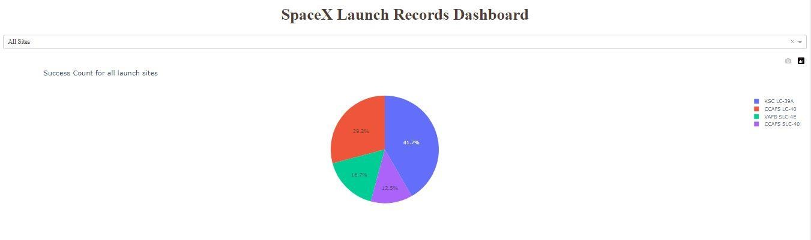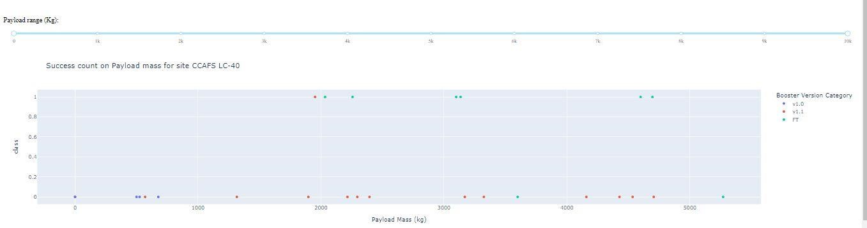

•

Summary of

how

I

built, evaluated, improved, and found the best

performing

classification

model

•

After loading the data as a Pandas Dataframe, I set

out to perform

exploratory Data Analysis and determine Training

Labels by;

•

creating

a NumPy

array from the column Class in data, by applying the method

to_numpy() then

assigned

it to the variable

Y as the outcome variable.

•

Then standardized the feature

dataset

(

x) by transforming it using

preprocessing.StandardScaler

()

function from Sklearn.

•

After

which the data was

split into

training

and testing

sets using

the function

train_test_split from sklearn.model_selection with

the test_size parameter set to

0.2

and random_state to

2.

Predictive Analysis (Classification)

# Predictive Analysis (Classification)

* In order to find the best ML model/ method that would performs best using the test data between SVM, Classification Trees, k nearest neighbors and

Logistic Regression;

* First created an object for each of the algorithms then created a GridSearchCV object and assigned them a set of parameters for each model.
* For each of the models under evaluation, the GridsearchCV object was created with cv=10, then fit the training data into the GridSearch object for each to Find best Hyperparameter.
* After fitting the training set, we output GridSearchCV object for each of the models, then displayed the best parameters using the data attribute best_params_ and the accuracy on the validation data using the data attribute best_score_.
* Finally using the method score to calculate the accuracy on the test data for each model and plotted a confussion matrix for each using the test and predicted outcomes.



•

The table below shows the test data accuracy score for each of the

methods comparing them to show which performed

best using

the test data

between SVM

, Classification Trees, k nearest neighbors and Logistic

Regression;

•

GitHub URL of the completed predictive analysis lab

(

https://github.com/cgatama/SpaceX

-

Falcon

-

9

-

1

st

-

stage

-

Success

-

Landing

-

Prediction/blob/main/8.%20SpaceX%20Machine%20Learning%20Prediction.ipynb

)

Predictive Analysis (Classification)

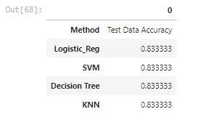

•

Exploratory data analysis results

•

Interactive analytics demo in screenshots

•

Predictive analysis results

Results

Section 2



A

scatter plot of

Flight Number vs. Launch

Site

Flight Number vs. Launch

Site

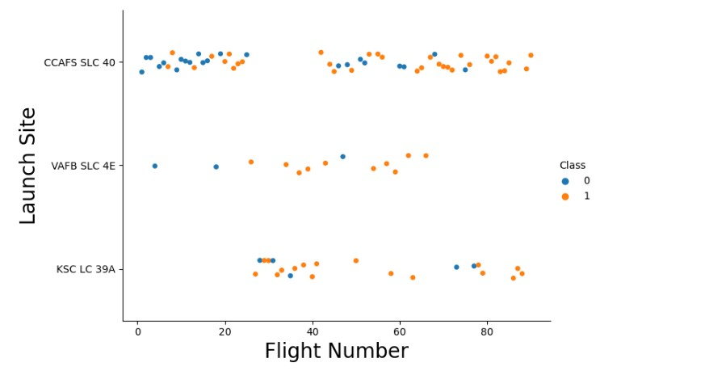

Flight Number vs. Launch

Site with explanations

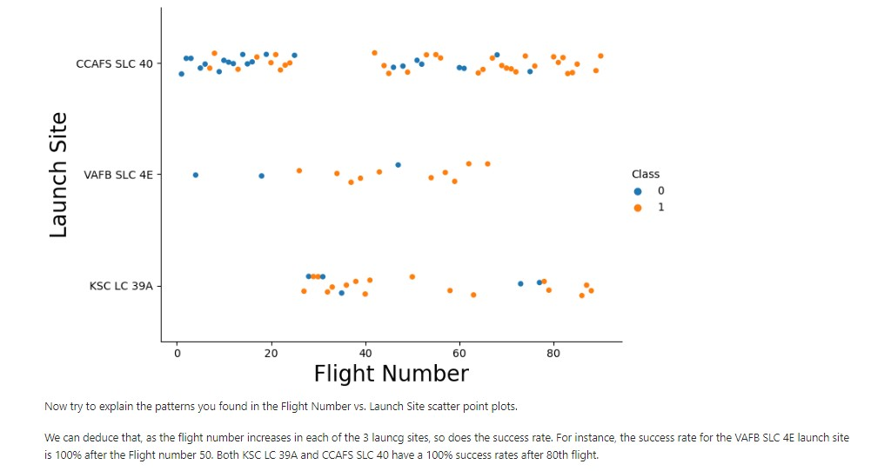

A scatter

plot with explanations Flight Number vs. Launch

Site



A

scatter plot of

Payload vs. Launch

Site

Payload vs. Launch Site

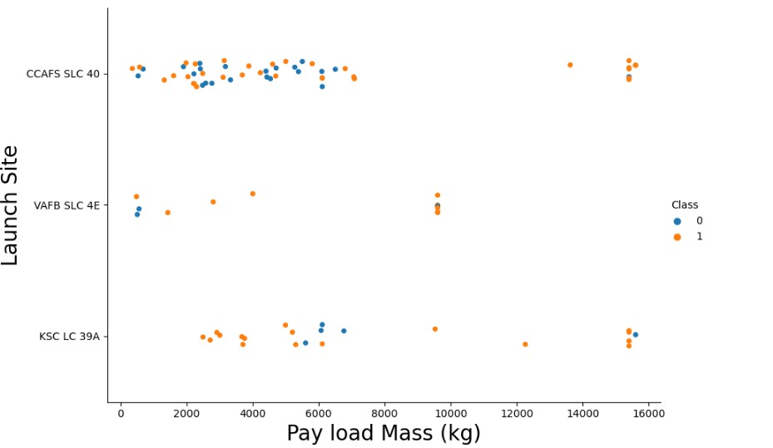

Payload vs.

Launch Site with explanations

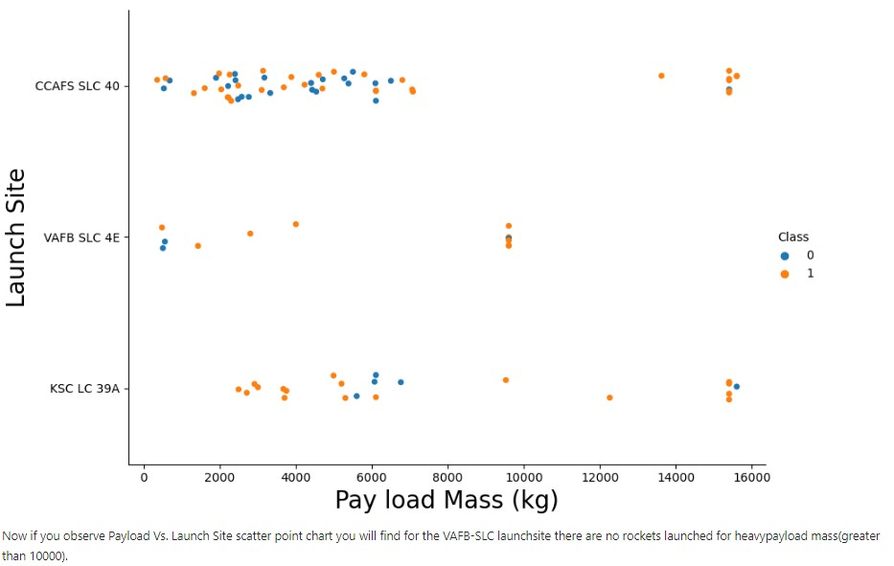

A scatter

plot of Payload vs. Launch Site



•

Show a

bar chart for the success rate of each orbit

type

Success Rate vs. Orbit Type

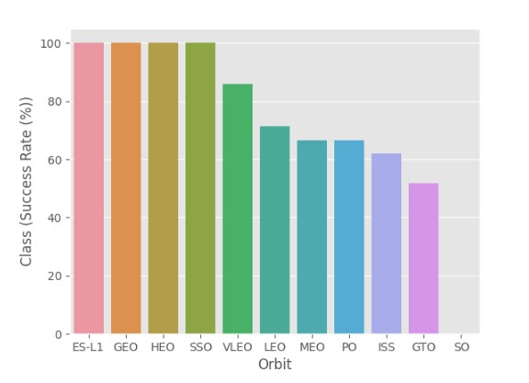

•

Show

the screenshot of the bar chart with explanations

Success Rate vs.

Orbit Type with explanations

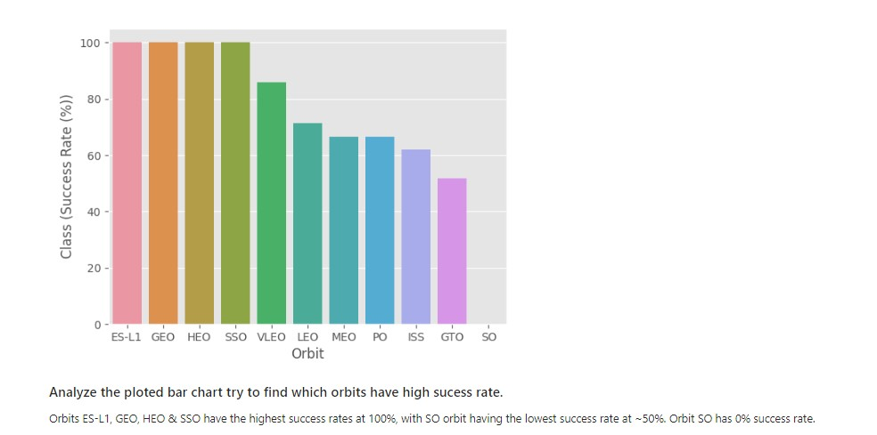

•

A

scatter

point of

Flight number vs.

Orbit type

Flight Number vs. Orbit Type

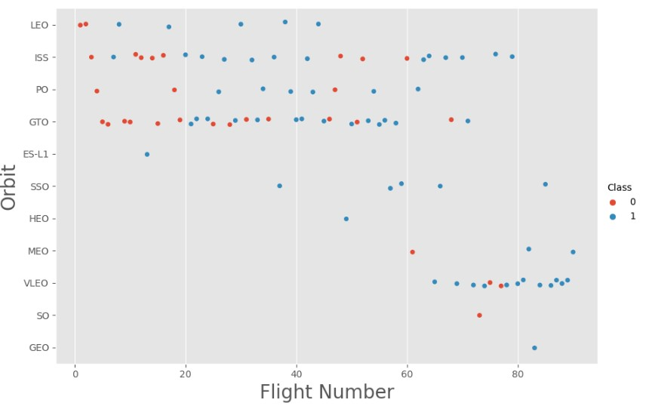

Flight Number vs.

Orbit Typewith explanations

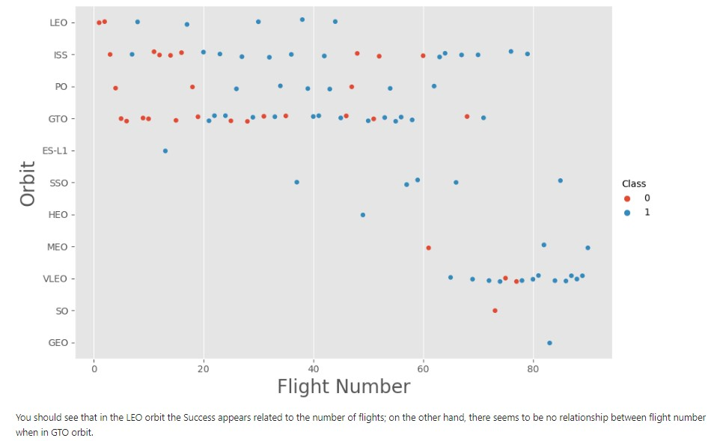

•

With heavy

payloads the

successful landing

or positive landing

rate are more for

Polar,LEO and ISS.

•

However for GTO

we cannot

distinguish this well

as both positive

landing rate and

negative

landing(unsuccessfu

l mission)

both have

near equal chances.

Payload vs. Orbit

Type

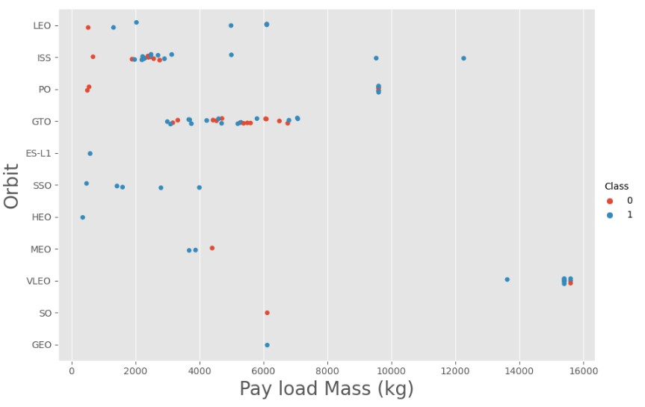

•

Since 2013, the

success rate

kept going up

till 2020

Launch Success Yearly Trend

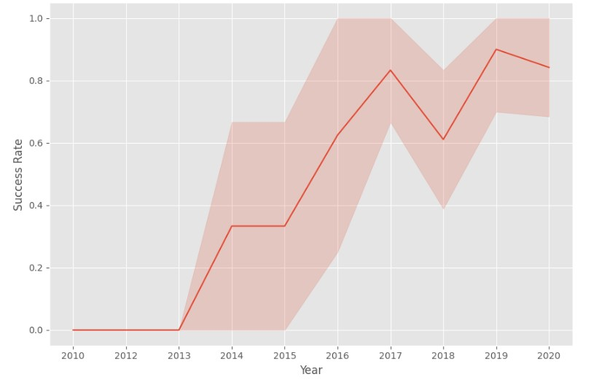

A

line chart of yearly average success rate



•

Find the names of

the unique

launch

sites

•

Used ‘SELECT

DISTINCT’ statement

to return only the

unique launch sites

from the

‘LAUNCH_SITE’

column of the

SPACEXTBL table

All Launch Site Names

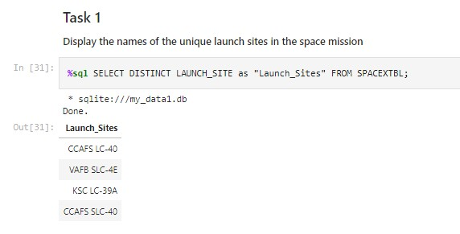

•

Find 5 records where launch sites begin with `

CCA

`

Launch Site Names Begin with 'CCA'

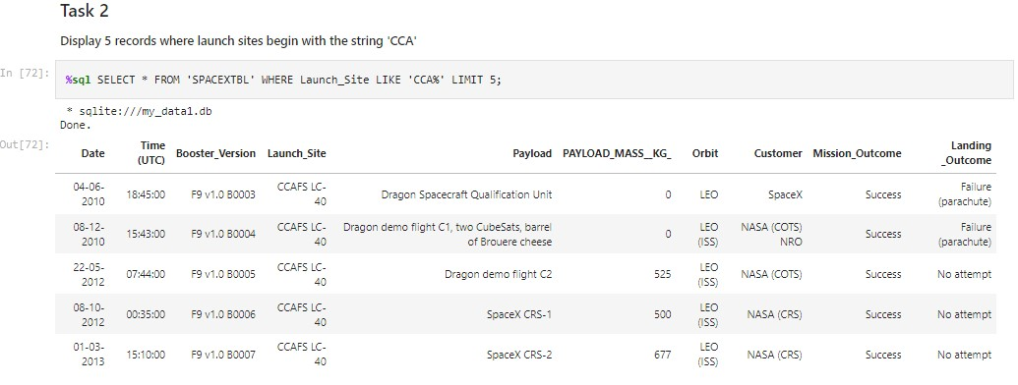

•

Used ‘LIKE’ command with ‘%’ wildcard in ‘WHERE’ clause to select and dispay a table of all records where

launch sites begin with the string 'CCA

'



•

Calculate

and Display the

total payload carried by boosters from

NASA

Total Payload Mass

•

Used the ‘SUM()’ function to return and

dispaly

the total sum of

‘

PAYLOAD_MASS_KG

’ column for Customer ‘

NASA(CRS

’

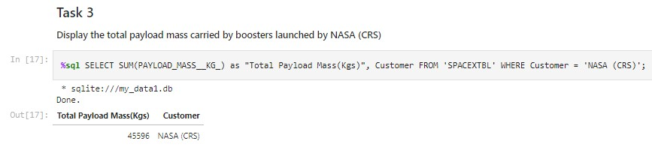

•

Calculate the average payload mass carried by booster version F9

v1.1

Average Payload Mass by F9 v1.1

•

Used the

‘AVG()’

function to return and dispaly the average payload mass

carried by booster version F9 v1.1

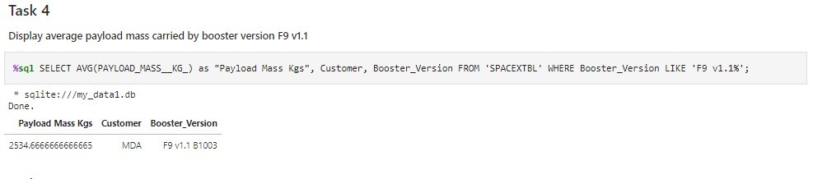

•

Find the dates of the first successful landing outcome on

ground

pad

First Successful Ground Landing Date

•

Used the

‘MIN()’

function to return and dispaly the

first (oldest) date when

first

successful landing outcome on ground

pad ‘

Success (ground pad)

’happened.

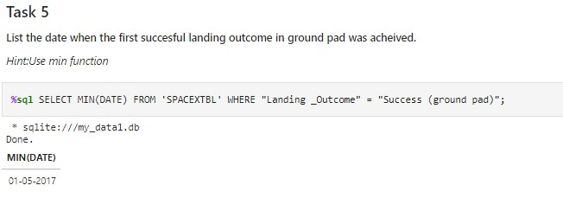

•

List

of Boosters

which have successfully landed on drone ship and had payload

mass greater than 4000 but less than

6000

Successful Drone Ship Landing with Payload between 4000 and 6000

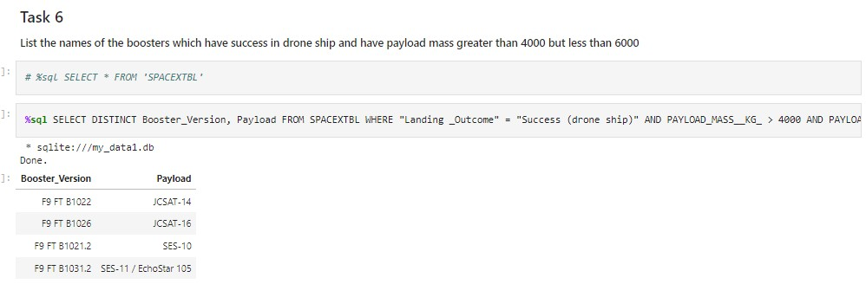

•

Used ‘Select Distinct’ statement to return and list the ‘unique’ names of boosters with

operators >4000 and <6000 to only list booster with payloads btween 4000

-

6000

with

landing outcome of ‘Success (drone ship)’.



•

Calculate the total number of successful and failure mission

outcomes

Total Number of Successful and Failure

Mission Outcomes

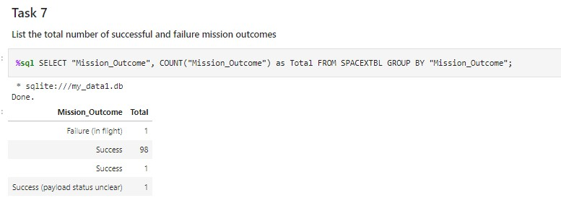

•

Used the ‘COUNT()’ together with the ‘GROUP BY’ statement to return

total number of missions outcomes



Boosters Carried Maximum

Payload

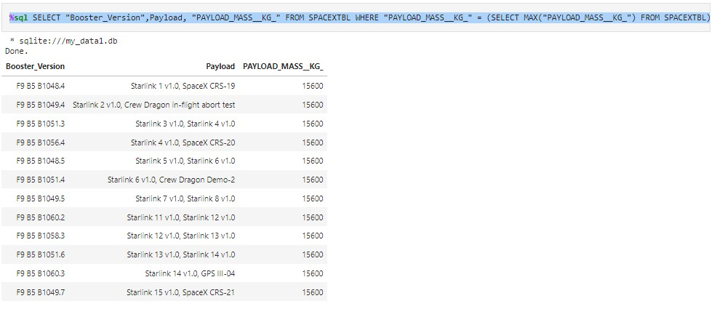

•

Using a Subquerry to return and pass the Max payload and used it list all the

boosters that have carried the Max payload of 15600kgs

•

List

of

the

boosters

which have carried the maximum

payload

mass



•

List

of

failed

landing outcomes

in drone ship

,

with their

booster versions,

and

launch site

names

in

2015

2015

Launch Records

•

Used the ‘subsrt()’ in the select statement to get the month and year from the date column

where substr(Date,7,4)='2015' for

year and Landing_outcome was ‘Failure (drone ship’)

and return the records nmatching the filter.

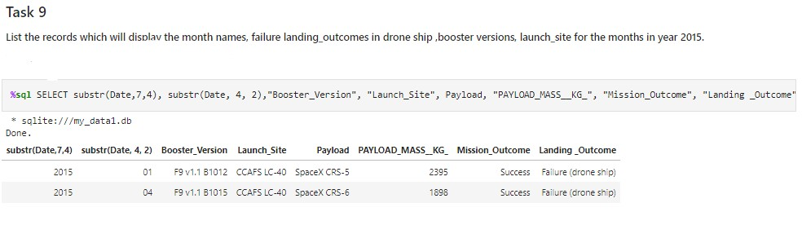

Rank Landing Outcomes Between 2010

-

06

-

04

and

2017

-

03

-

20

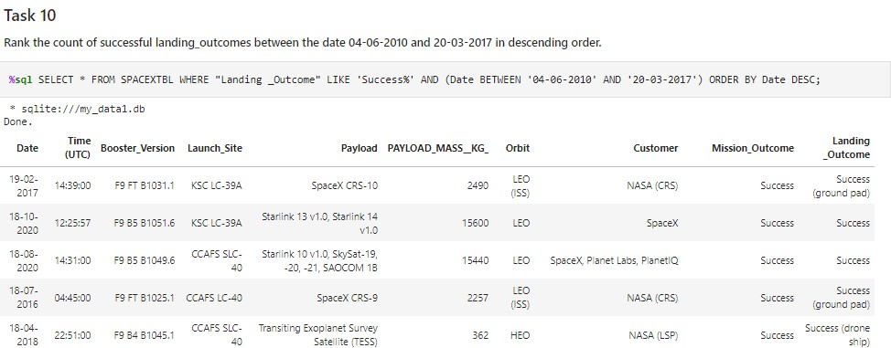

•

Rank the count of landing outcomes (such as Failure (drone ship) or Success

(

ground pad)) between the date

2010

-

06

-

04

and

2017

-

03

-

20

, in

descending

order

Section 3



Markers of

all launch sites on

global

map

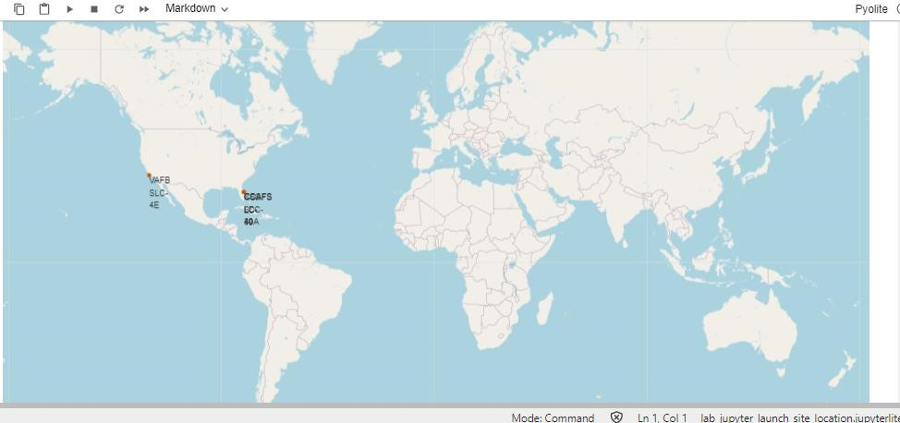

•

All launch

sites

are in

proximity to the

Equator, (located southwards of the US

map). Also all the laumch sites are in very close proximity to the coast.



•

In the Eastern coast (Florida) Launch site

KSC

LC

-

39

A

has relatively high success

rates compared to CCAFS

SLC

-

40

&

CCAFS

LC

-

40.

Florida Sites

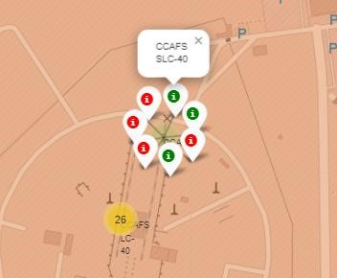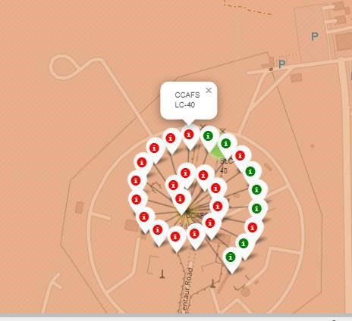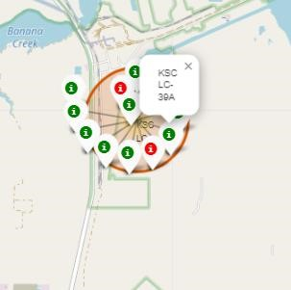

L

aunch outcomes for

each site on the

map With Color

Markers



•

In the West Coast

(

Californai) Launch

site

VAFB

SLC

-

4

E

has

relatively

lower

success rates

4

/10

compared

to KSC

LC

-

39

A launch site in the

Eastern Coast of

Florida.

West Coast/ Carlifonia

L

aunch outcomes for

each site on the

map With Color

Markers

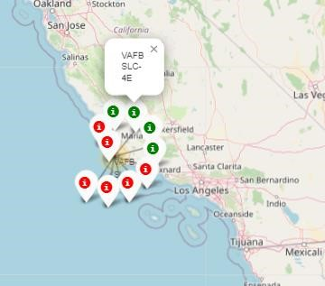

•

Launch site

CCAFS

SLC

-

40

proximity to coastline is 0.86km

Distances

between a launch site to its proximities

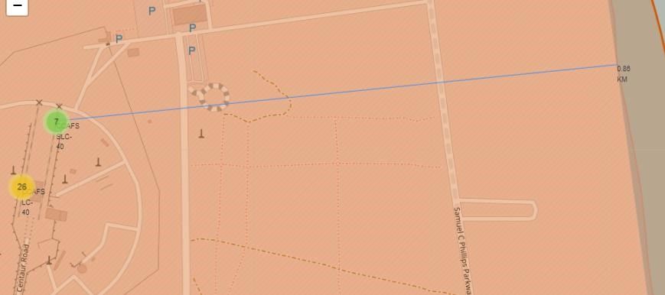

•

Launch site

CCAFS

SLC

-

40

closest to highway (Washington

Avenue) is 23.19km

Distances

between a launch site to its proximities

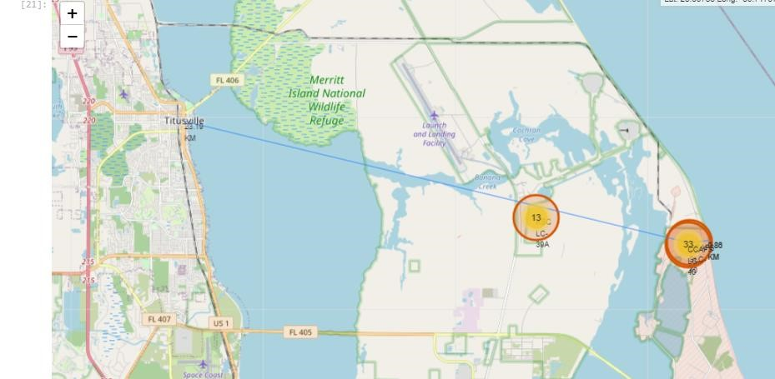

Section 4



•

Launch site KSC LC

-

39

A has the highest launch success rate at

42

%

followed by CCAFS

LC

-

40

at

29

%,

VAFB SLC

-

4

E at 17% and lastly launch site CCAFS

SLC

-

40

with a success

rate of 13%

Pie

-

Chart for launch

success count for all

sites



51

•

Launch site CCAFS

LC

-

40

had the

2

nd

highest success ratio of 73% success

against 27% failed launches

Pie chart

for the launch site with

2

nd

highest

launch success ratio

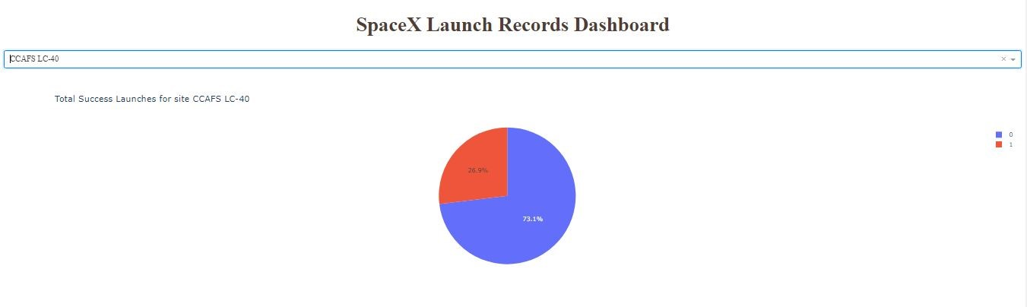

•

For

Launch site

CCAFS LC

-

40

the booster version FT has

the largest success

rate

from a payload mass of >2000kg

Payload vs. Launch Outcome scatter plot for all sites

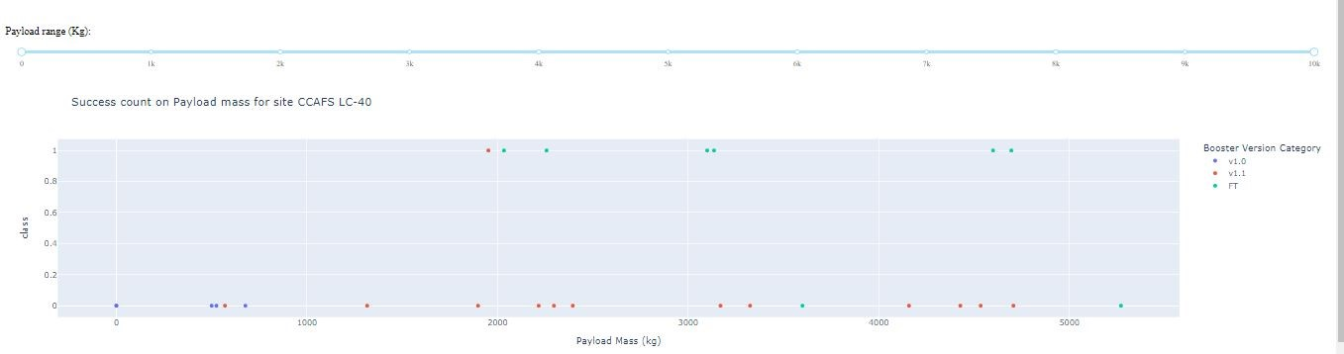

Section 5



Classification

Models Accuracy

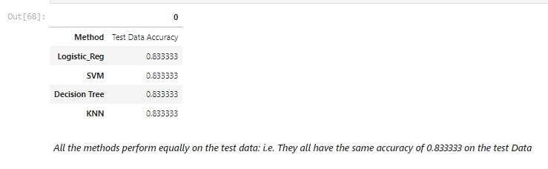

•

All the 4

classification

model had the

same confusion

matrixes

and

were able equally

distinguish

between

the

different classes.

The

major

problem is false

positives for all

the models.

Confusion Matrix

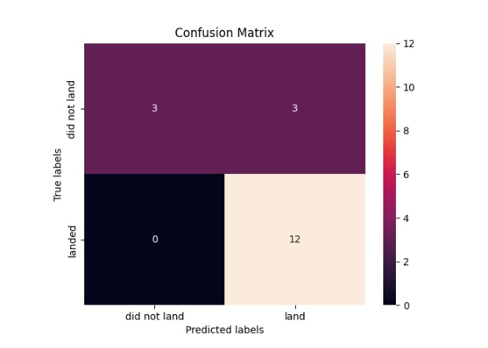

# Conclusions

* Different launch sites have different success rates. CCAFS LC-40, has a success rate of 60 %, while KSC LC-39A and VAFB SLC 4E has a success rate of 77%.
* We can deduce that, as the flight number increases in each of the 3 launcg sites, so does the success rate. For instance, the success rate for the VAFB SLC 4E launch site is 100% after the Flight number 50. Both KSC LC 39A and CCAFS SLC 40 have a 100% success rates after 80th flight
* If you observe Payload Vs. Launch Site scatter point chart you will find for the VAFB-SLC launchsite there are no rockets launched for heavypayload mass(greater than 10000).
* Orbits ES-L1, GEO, HEO & SSO have the highest success rates at 100%, with SO orbit having the lowest success rate at ~50%. Orbit SO has 0% success rate.
* LEO orbit the Success appears related to the number of flights; on the other hand, there seems to be no relationship between flight number when in GTO orbit



•

With heavy payloads the successful landing or positive landing rate are more for

Polar,LEO and

ISS. However

for GTO we cannot distinguish this well as both positive

landing rate and negative landing(unsuccessful mission) are both there

here

•

Anf finally the sucess rate since 2013 kept increasing till

2020.

Conclusions Cont….

